Functional User Stories

DOD Portal

This document describes the Functional Solution of the system. The document intends to outline the solution by incorporating user stories and screen designs for the project as agreed between the Business Application Owner, all other impacted parties and the IT community.

Version 0.8

# Document Control

The latest published version of this document is located here:

|  |  |  |  |
| --- | --- | --- | --- |
| **Version** | **Date** | **Author** | **Comments** |
| 0.2 | 28/01/2017 | Shad | Create |
| 0.3 | 08/02/2017 | Adrian Buttigieg | Review |
| 0.4 | 16/02/2017 | May Lozano  Shad | Database entities and ER diagrams  Mobile wireframe designs  User roles and user settings screens  3 report mock designs |
| 0.5 | 20/02/2017 | Shad | Sign up screen  Mobile DOD Activity Report  Mobile HACCP Report |
| 0.6 | 28/02/2017 | May Lozano  Shad | Architecture diagram  Formatting and wireframe changes |
| 0.7 | 17/03/2017 | Shad | Wireframe enhancements and added features. |
| 0.8 | 30/03/2017 | Shad | Added Protocosl section. |

# Contents

Document Control 2

Contents 3

Executive Summary 4

Background 4

Business Objectives for this Project 4

Scope 4

Definition of Points 4

Supported Platform 4

Application development platform 4

Protocols 4

Source-code ownership 4

PLAN 6

Stage 1 7

1.1 Login and Registration – A user can sign up for the site 7

1.2 Login and Registration – An administrator has to approve registration requests 8

1.3 Landing Page/Main Menu – A user has access to key elements of the application 8

1.4 Configuration – A user can change site 9

1.5 Configuration – A user can add a DOD device for the site 11

1.6 Configuration – A user can view/modify DOD devices for the site 12

1.7 Configuration – Alerts Page 13

1.8 Configuration – User Roles 16

1.9 Configuration – User Settings 17

1.10 Configuration – User Configuration (Administrator) 18

Stage 2: Reports 19

2.1 Reports – view by DOD 19

Architecture 25

Database Entities 26

Timeline 32

Appendix 33

A2 Decisions & Implications 33

A3 Definitions, Acronyms and Abbreviations 33

A3 Table of figures 33

A4 References 33

Executive Summary

This section is for an Executive Summary. It may be easier to first complete the Detailed Functional Solution and then complete the summary.

Background

Defrost On-Demand (DOD) devices are peripherals attached to refrigeration assets that are held on store premises. The purposes of these DOD devices is to collect temperature data from those refrigeration devices, which can be used to monitor and diagnose the state of the refrigerators.

Business Objectives for this Project

* Use the source content from the Business Solution Management Report (BSMR for 4QD) or High Level Requirements.& Solution Definition (HLRSD) document

To develop an application to administer, monitor and report on DOD devices. The web applications are to be responsive accessible from web browser.

Scope

This document has been created to detail the requirements related to the development of a DOD web application. This document has also been used to break the project into different stages and estimate each.

Definition of Points

To estimate the development effort of the DOD application, each user story was reviewed (As per scrum methodology – for a maximum period of 2mins) and points were assigned. Points are an Agile concept to express how complex the development team believes a requirement is. Points are used to indicate a scale, 1 indicates a simple task and 13 being the most complex. (Based on the sequencing of Fibonacci) This number was then loosely related to hours. As development continues the estimation of effort will continue to change as requirements are refined and discovered.

Supported Platform

DOD web application will be developed to support the following versions and above :-

1. Google Chrome 34+
2. Internet Explorer 10+
3. Safari 10+

As responsiveness is a priority for the DOD the mobile version of the above browsers is also to be supported.

Application development platform

The application is to be devloped using the following

* MS SQL Server 2014 in Azure PAAS.
* MVC 4/5
* AngularJS, Node.js, TypeScript
* C# .Net
* HTML5

Protocols

* HTTPS – Allow only secured connections to the web application.
* Modbus – for transmission of information over serial lines between electronic devices (DOD client to server).

Source-code ownership

City Facilities Management Sdn Bhd will retain ownership towards the source-code of the application. The source code are to be made available at the end of each 2-weeks Sprint, and delivered in full at completion of the project.

PLAN

|  |  |
| --- | --- |
| Item | Status |
|  |  |
|  |  |
|  |  |
|  |  |
|  |  |
|  |  |
|  |  |
|  |  |
|  |  |
|  |  |
|  |  |
|  |  |
|  |  |
|  |  |
|  |  |
|  |  |

# Stage 1

**Objective :** Browse stores. Add, view, and edit DOD devices.

**Total Point:**

**Total Hours:**

**Weeks:**

## Login and Registration – A user can sign up for the site



* **Username** is unique, alphaneumaric with no spaces. Mandatory field.
* **E-mail** is unique, check against invalid e-mail formats. Mandatory field.
* **Full name** alphaneumeric with no special characters. Mandatory field.
* **Role** desired role of the user, defaults to Customer.
* **Password** should be 8 characters or longer.

## Login and Registration – An administrator has to approve registration requests



## Landing Page/Main Menu – A user has access to key elements of the application

(Points: )

* The user has the ability to preview store configured for in the header of the application
* The user can **change site** , this filters information within all screens
* The user can view **Recent Alerts** for the store with a counter for the last 24hours (Figure 4, with filters auto-configured)
* The user can **add DOD** to a site
* The user can **view/modify DOD settings**
* The user can view **reports**
* The user can **configure alerts**
* Additional features made available on the hamburger menu.
  + The user can **change settings**
  + The user can **logout** of the application therefore removing credentials from cache



* Add DOD – A technician can add DOD to a site. Clicking on Add DOD leads to the DOD Set-Up screen (Figure 2).

## Configuration – A user can change site

(Points: )

* A user can view the store type with a counter of the total number of sites. This can be selected to then open a list of stores for that store type

Figure 1: Store list view (on mobile).



* A user can click on a store. This will return back to the Landing page/Main menu.

Figure 1.2: Site view

## Configuration – A user can add a DOD device for the site

(Points: )

A user of role “Technician” are able to add DOD devices to a site. The form holds the following fields:

* Serial number – numeric, mandatory field, restricted to 5 characters, unique.
* Asset tag – numeric, mandatory field, restricted to 12 characters.
* Location
  + Describes the host device
  + Alpha numeric, mandatory field.
* Ideal Defrost Per Day – numeric
* Ideal Temperature
  + High
  + Low
* Parameters
  + Based on the 31 parameters defined in DOD devices. Some of the parameters are read-only, some can be set by the users (refer Appendix A5, DOD Parameter List)

Figure 2: The Add DOD screen (viewed on desktop)



Figure 2.1: Add DOD screen (mobile)



* Touch-friendliness – all textboxes and buttons taller than they are on desktop.
* The parameters section is collapsible.
* Save and Discard button is fixed at the bottom of the screen.

## Configuration – A user can view/modify DOD devices for the site

(Points:)

A user can click on The view/modify DOD from a site’s summary screen will lead to a list of DOD devices located on that premise.

* Grid contains a list of all DOD devices.
* Columns:
  + Location – host device of the DOD device
  + Serial No
  + Asset Tag – refers to the dod device
  + Alerts Badge – number of alerts that the device currently has. Clicking on the badge opens the 1.5 Alerts page filtered for that DOD device
  + Edit button – will open the Add DOD loaded with the asset information in Edit Mode. Change the banner from Add DOD to edit DOD.
  + Reports button – will open the Reports page where reports are pre-filtered for that asset/DOD

Figure 3: The Site > “View/Modify DOD” screen on desktop browser

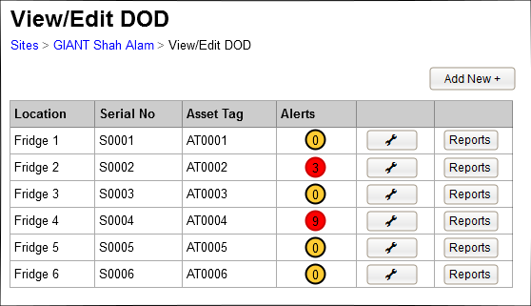

Figure 3.1: The Site > “View/Modify DOD” screen on mobile



* The rows as represented on the desktop version becomes a “card” on the mobile version.
* Each card’s header is the DOD’s serial number.
* Three action icons at the bottom of each card, from left to right:
  + - View reports
    - Alert (with indicator for active alerts), turns orange if active alert > 0
    - Edit DOD, leads to the edit page (see figure 2.1)

## Configuration – Alerts Page

(Points: )

The site listens to alerts raised by the DOD devices, and stores the alerts history in the database.

Figure 4: Alerts screen (desktop)



* Default view for the last 24 hours for all types
* Grouping by DOD devices.
* User has the ability to filter the grid by changing the type – multi-selection combo box, allows the user to filter the alerts by Alert type. All is the default setting.
* User has the ability to filter the grid by changing the date – combo box, with options:
  + Last Hour – shows only alerts that occurred within the last hour
  + Today (default)
  + This week
  + This month
  + Range – choosing this option will enable the from and to field, which allows the user to choose dates from a calendar control
* Users has the ability to filter by location. All is the default setting.
* Grid developed to include
  + Date & Time
  + Alarm Type
  + Description
  + Location
  + Serial
  + Asset Tag

Figure 4.1: Alerts screen (mobile)



Figure 4.2: Alerts screen (mobile) - filters



## Configuration – User Roles

(Points: )



Roles:

* Administrator (super user)
* Technician
* Customer
  + Administrators are able to create new roles

Permissions:

* View DOD devices
* Add DOD devices to site
* Edit DOD device
* View reports
* Configure alerts
* Configure parameters
* Configure users
* Configure user roles

Default configurations:

|  |  |  |  |
| --- | --- | --- | --- |
|  | ADMINISTRATOR (SUPER USER) | Technician | Customer |
| View DOD devices | Yes | Yes | Yes |
| Add DOD deviceS to site | Yes | Yes | No |
| Edit DOD device | Yes | Yes | No |
| View reports | Yes | Yes | Yes |
| Configure alerts | Yes | Yes | Yes |
| Configure parameters | Yes | Yes | No |
| configure users | Yes | No | No |
| configure user roles | Yes | No | No |

## Configuration – User Settings



* Can be accessed from the hamburger menu from the main landing page.
* The username field is readonly.
* Selection of preferred temperature unit, with options:
  + Celcius
  + Fahrenheit
  1. Configuration – User Configuration (Administrator)



* Page is only accessible by an adiministrative user.
* User can be assigned to a role. The role dropdown will be populated with roles configured in User Roles setup (see 1.6).
* It is possible to set the user to deactivated, and disables their access to the site. A deactivated user can be re-activated.
* A label below the deactivate button clarifies what Deactivate means.

# Stage 2: Reports

**Objective:** Gathering of information from DOD device data

**Total Point:**

**Total Hours:**

**Weeks:**

## 2.1 Reports – view by DOD

(Points 0)



* Accessible form the main menu by the user by clicking Reports
* Site-specfic reports listed under the Site subheader.
* All-Sites reports shows under the All Sites subheader, regardless of which Site is currently viewed.

Report1 – DOD Activity



* Default view of current state of temperature and airflow detected the dod device
* Users has the ability to filter by location. All is the default setting.
* Grid developed to include
  + Location
  + Serial
  + Asset Tag
  + Temp in degrees or Fahrenheit



Report 2 – HACCP



* Default view of HACCP hourly interval data pulled yesterday from 12am to 11:59pm from each DOD device and stored on backend tables
* Users has the ability to filter by location. All is the default setting.
* Grid developed to include
  + Location
  + Serial
  + Asset Tag
  + Low – Configured Sepint
  + High – Configured setpoint

00,01,02 etc – hours throughout the day

* User can view exscptionin red where tempaeratuie is out side iof threshold Low & High
* User can see the temerparure redings recordedat hourly intervals



Report 3 – DOD offline /HACCP Exception report all sites



Mobile view of the report

* Mobile view - A user can view by store type in alapahebtical order with a count of the number of dod not reporting temperature data for the last 24hours.
* Mobile view - A user can tap on the + button to expand and show all sites in alphabetical order with a counter of number of number of dod not reporting temperature data foor the last 24hours.
* Mobile view - A user can tap on the + button to expand and show Location, Serial No, Asset in one field

# Architecture



# Database Entities

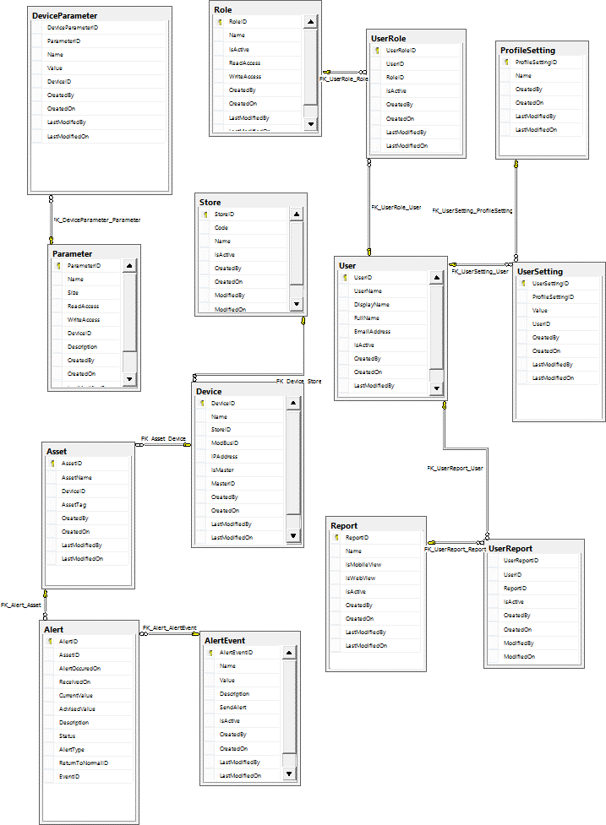

DOD Database Entities Relationship

* **Store**

|  |  |
| --- | --- |
| **Entity** | **Description** |
| StoreID | Identity column |
| Code | Store code |
| Name | Name of the store |
| IsActive | Whether store is currently active |
| CreatedBy | ID of the user who created the store in the system |
| CreatedOn | Date when store was created in the system |
| LastModifiedBy | ID of the last user who modified the store in the system |
| LastModifiedOn | Date when store was last modified in the system |

* **User**

|  |  |
| --- | --- |
| **Entity** | **Description** |
| UserID | Identity column |
| DisplayName | Name to be shown in the display screen, if needed. |
| FullName | Full name of the user |
| EmailAddress | Email Address |
| IsActive | Whether user is active in the system |
| CreatedBy | ID of the user who created the user in the system |
| CreatedOn | Date when user was created in the system |
| LastModifiedBy | ID of the last user who modified the user in the system |
| LastModifiedOn | Date when user was last modified in the system |

* **Role**

|  |  |
| --- | --- |
| **Entity** | **Description** |
| RoleID | Identity column |
| Name | Name of the role (e.g. Technician Administrator, Technician, Developer) |
| IsActive | Whether role is active in the system |
| ReadAccess | Whether role has permission to read |
| WriteAccess | Whether role has permission to write |
| CreatedBy | ID of the user who created the role in the system |
| CreatedOn | Date when role was created in the system |
| LastModifiedBy | ID of the last user who modified the role in the system |
| LastModifiedOn | Date when role was last modified in the system |

* **UserRole**

|  |  |
| --- | --- |
| **Entity** | **Description** |
| UserRoleID | Identity column |
| UserID | ID of the user who needs permission to role |
| RoleID | ID of the role that need permission to |
| IsActive | Whether permission is active in the system |
| CreatedBy | ID of the user who created the user role in the system |
| CreatedOn | Date when user role was first granted in the system |
| LastModifiedBy | ID of the last user who modified the user role in the system |
| LastModifiedOn | Date when user role was last modified in the system |

* **ProfileSetting**

|  |  |
| --- | --- |
| **Entity** | **Description** |
| ProfileSettingID | Identity column |
| Name | Name of the profile setting (e.g. Temperature, Timezone) |
| CreatedBy | ID of the user who created the profile setting in the system |
| CreatedOn | Date when profile setting was created in the system |
| LastModifiedBy | ID of the last user who modified the profile setting in the system |
| LastModifiedOn | Date when profile setting was last modified in the system |

* **UserSetting**

|  |  |
| --- | --- |
| **Entity** | **Description** |
| UserSettingID | Identity column |
| ProfileSettingID | ID of the profile setting |
| Value | Value of the user setting (e.g. Celsius/Fahrenheit) |
| UserID | ID of the user for this setting |
| CreatedBy | ID of the user who created the user setting in the system |
| CreatedOn | Date when user setting was created in the system |
| LastModifiedBy | ID of the last user who modified the user setting in the system |
| LastModifiedOn | Date when user setting was last modified in the system |

* **Device**

|  |  |
| --- | --- |
| **Entity** | **Description** |
| DeviceID | Identity column |
| Name | Name of the defrost device |
| StoreID | Store ID of the store where the defrost device is installed |
| ModBusID | ModBus ID |
| IPAddress | IP Address of the defrost device to communicate to the network |
| IsMaster | Whether device is a master device |
| MasterID | If yes, input the master ID (referencing ID to same table) |
| CreatedBy | ID of the user who created the device in the system |
| CreatedOn | Date when device was created in the system |
| LastModifiedBy | ID of the last user who modified the device in the system |
| LastModifiedOn | Date when device was last modified in the system |

* **Parameter**

|  |  |
| --- | --- |
| **Entity** | **Description** |
| ParameterID | Identity column |
| Name | Name of the parameter (e.g. Hardware Version, Serial Number, Defrost Request) |
| Size | Size (8 or 16-bit words) of the parameter |
| ReadAccess | Whether parameter can be read |
| WriteAccess | Whether parameter can be written |
| DeviceID | ID of the defrost device from master or slave |
| Description | Description of the parameter |
| CreatedBy | ID of the user who created the parameter in the system |
| CreatedOn | Date when parameter  was initially in the system |
| LastModifiedBy | ID of the last user who modified the parameter  in the system |
| LastModifiedOn | Date when parameter  was last modified in the system |

* **DeviceParameter**

|  |  |
| --- | --- |
| **Entity** | **Description** |
| DeviceParameterID | Identity column |
| ParameterID | ID of the defrost device parameter |
| Name | Name of the |
| Value | Value of the device parameter |
| DeviceID | ID of the defrost device |
| CreatedBy | ID of the user who created the device parameter in the system |
| CreatedOn | Date when device parameter was initially in the system |
| LastModifiedBy | ID of the last user who modified the device parameter in the system |
| LastModifiedOn | Date when device parameter was last modified in the system |

* **Asset**

|  |  |
| --- | --- |
| **Entity** | **Description** |
| AssetID | Identity column |
| AssetName | Name of the asset (e.g. Freezr Rm) |
| DeviceID | ID of the defrost device |
| AssetTag | Asset tag |
| CreatedBy | ID of the user who created the asset in the system |
| CreatedOn | Date when asset was created in the system |
| LastModifiedBy | ID of the last user who modified the asset in the system |
| LastModifiedOn | Date when asset was last modified in the system |

* **Alert**

|  |  |
| --- | --- |
| **Entity** | **Description** |
| AlertID | Identity column |
| AssetID | ID of the asset |
| AlertOccuredOn | Date when alert has occurred |
| ReceivedOn | Date when alert is received |
| CurrentValue | Current value of the sensor |
| AdvisedValue | Advised value of the sensor |
| Description | Reason alert is active |
| Status | Status of the alert |
| AlertType | Type of alert (e.g. Alarm or ReturnedToNormal) |
| ReturnToNormalID | ID of returned to normal alert |
| EventID | ID of the event |

* **AlertEvent**

|  |  |
| --- | --- |
| **Entity** | **Description** |
| AlertEventID | Identity column |
| Name | Name of the event (e.g. Overheating, hardware failure) |
| Value | Value of the event (e.g. On/Off, above 30C temp) |
| Description | Description of the event |
| SendAlert | Whether alert should be sent out |
| IsActive | Whether event is active in the system |
| CreatedBy | ID of the user who created the alert event in the system |
| CreatedOn | Date when alert event was created in the system |
| LastModifiedBy | ID of the last user who modified the alert event in the system |
| LastModifiedOn | Date when alert event was last modified in the system |

* **Report**

|  |  |
| --- | --- |
| **Entity** | **Description** |
| ReportID | Identity column |
| Name | Name of the report (e.g. HACCP, DOD Activity) |
| IsMobileView | Report view is for mobile |
| IsWebView | Report view is for web browser |
| IsActive | Whether event is active in the system |
| CreatedBy | ID of the user who created the report in the system |
| CreatedOn | Date when report was created in the system |
| LastModifiedBy | ID of the last user who modified the report in the system |
| LastModifiedOn | Date when report was last modified in the system |

* **UserReport**

|  |  |
| --- | --- |
| **Entity** | **Description** |
| UserReportID | Identity column |
| UserID | ID of the user who has access to the report |
| ReportID | ID of the report |
| CreatedBy | ID of the user who granted access to report in the system |
| CreatedOn | Date when user access to report was granted in the system |
| LastModifiedBy | ID of the last user who modified the user access to the report in the system |
| LastModifiedOn | Date when user access to report was last modified in the system |

# Timeline

|  |  |  |  |  |  |
| --- | --- | --- | --- | --- | --- |
| Stage | Objective | Total Points | Total Hours | Weeks |  |
| Stage 1 |  |  |  |  |  |
| Stage 2 |  |  |  |  |  |
| Stage 3 |  |  |  |  |  |
| Stage 4 |  |  |  |  |  |
| Stage 5 |  |  |  |  |  |
| Stage 6 |  |  |  |  |  |
| Stage 7 |  |  |  |  |  |
| Stage 8 |  |  |  |  |  |
| Total |  |  |  |  |  |

Use the source content from the BSMR (4QD) or HLRSD .

Appendix

A2 Decisions & Implications

[Insert text]

List the key design decisions and implications that this project faces. For example, a specific design for an interface may prevent

A3 Definitions, Acronyms and Abbreviations

For ease of use, sort this table into Abbreviation & Expanded Term sequence.

Add any terms that you think may be confusing to readers of this document. Some terminology is known and taken for granted within a group, but will be unknown to others outside that group. Consider also terminology that has had changed meaning over time.

|  |  |
| --- | --- |
| **Term** | **Definition** |
|  |  |
|  |  |
|  |  |
|  |  |

A3 Table of figures

A4 References

Business Request Brief<application name>

Feasibility Document<application name>

Business Requirements Document, <application name>

Project Charter, <application name>

Project Management plan, <application name>

Solution Architecture <application name>

Business Solution Management Report (4QD only)

High Level Requirements & Solution Definition (4QD Lite only)

DRP Recovery Strategy, A Guideline for Developing